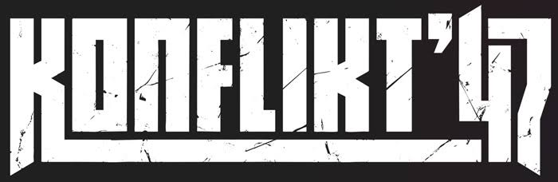

Generals Outpost are hosting a K47 Tournament

“The Horror”

Saturday 15th August 2026, 09:00-17:00
Denewell Ave URC hall. Low Fell, Gateshead. NE9 5HD
£15 (free to club members)

This will be our 1st ever 2nd edition K47 Tournament!

The Theme for this event is “The Horror”.

The Germans are working on a new terrifying weapon and are about to unleash it on an unsuspecting world.

Join the struggle to gather intelligence as to its terrible powers or help to secure its secrets.

Games: Three 135-minute games throughout the day (2hrs 15 mins)

Force limits: 1500pts. 20 Order Dice limit.

Mission Briefings: will be received on the day of the tournament for the three games being played.

Army list submissions: Please ensure that your army list is submitted before the event for verification.

Trophies and Awards: as well as the event winner we also have a selection of prizes for:

- Top Three Generals
- Most sporting general (voted for by the players)
- Best presented force (voted for by the players)
- Most cinematic moment (self-nominations)
- FUBAR awards (self-nominations)
- Wooden Spoon
- One random event attendee
Event timings

08:30 Door open (please try to arrive before 09:00 for a prompt start)
Refreshments available.

09:00 Introduction. Prep for 1st game.

09:30-11:45 Game #1.

11:45-12:30 Lunch

12:30-14:45 Game #2

14:45-15:00 Break

15:00-17:15 Game #3

17:20 Awards and teardown

17:30 Event ends.

Useful info
Address of event: Denewell Ave URC hall. Low Fell, Gateshead. NE9 5HD.

Parking: A limited number of parking spats are available outside the hall and on Denewell Ave. but please be respectful of people’s driveway access and park accordingly. The nearest paid car park is at Lowerys Lane, Low Fell. A short 5 minute walk from the hall.

Tournament Organisers:
- Chris Bucknall. 07703580449. cmbucknall@yahoo.co.uk
- Jamie Bucknall

Max 20 places. To book a place: Please call or email Chris. Cost: £15 (free to club members)

Tea, Coffee, juice and biscuits freely available. Snazzy “pod” coffee 50p.

We love painted miniatures but understand that life sometimes gets in the way. Try and get your models to the usual 3 colour and based standard but don’t fret if they need to go into battle in factory grey.

**No offensive iconography on any units please**

All levels of playing ability & painting welcome.

