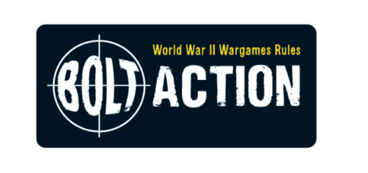
Generals Outpost are hosting a Bolt Action “Big Battle” Saturday
“El Alamein”

Saturday 14th March 2026, 09:00-17:00
Denewell Ave URC hall. Low Fell, Gateshead. NE9 5HD
£15 (free to club members)

32 Players, 4 Huge Tables. Come along and join the 2nd battle at El Alamein, North Africa. Can the Allies finally push Rommel out of Africa?

This huge Bolt Action game will span multiple tables and dice bags.

Players should select their forces from the following:

Allies

Great Britain (selected from the “Armies of Great Britain” book)
- Mid War
- 1250pts
- Inexperienced, regular or veteran

France (selected from the Amies of France .pdf)
- Mid War
- 1250pts
- Inexperienced, regular or veteran

Axis

Germany (selected from the “Armies of Germany” book)
- Mid War
- 1250pts
- Inexperienced, regular or veteran

Italy (selected from the “Armies of Italy” .pdf)
- Mid War
- 1250pts
- Inexperienced, regular or veteran

Axis players will also be given a chance to lay minefields and barbed wire and can also start with a limited number of units “dug in”.
Tables (Players can pre-select a table to play on or be assigned one on the day)

- Coast.
  - Battle at the railway station.
  - 6’x4’
  - 6 Players
- North.
  - Rocks and low hills.
  - 10’x4’
  - 8 Players
- Centre.
  - Open desert, great for tanks! Make sure your troops have transports.
  - 4’x6’
  - 6 Players
- South.
  - The old Fort. It dominates the landscape but will holding it bring victory?
  - 10’x4’
  - 8 Players

All three tables will be playing their games simultaneously with synchronised turns. There will be a handful of desert effects in play such as:

- Tanks being able to fire on the move (at a huge penalty to hit)
- Dust being kicked up by fast moving vehicles
- Minefields & the sappers clearing them
- Artillery Bombardments
- Limited air cover

These will be described more fully on the day.

Event timings
08:30 Door open (please try to arrive before 09:00 for a prompt start)
Refreshments available.
09:00 Mission Brief (All players)
09:05-09:15 Axis Setup
09:15-09:25 Allied Setup
09:25-12:15 Morning Gaming Session (turns 1-2)
12:15-13:00 Lunch – (includes announcement of club objective marker competition) 13:00-16:30 Afternoon Gaming Session (turns 3-6)
16:30 onwards Awards and teardown
17:00 Event ends

Useful info
Address of event: Denewell Ave URC hall. Low Fell, Gateshead. NE9 5HD.

Tournament Organisers:
- Chris Bucknall. 07703580449. cmbucknall@yahoo.co.uk
- Pete Harvey. 07837295306. paharvey@aol.com

Max 30 places. To book a place: Please call or email Chris or Pete ASAP as this event is already 90% is full. Cost: £15 (free to club members)

Tea, Coffee, juice and biscuits freely available. Snazzy “pod” coffee 50p.

We love painted miniatures but understand that life sometimes gets in the way. Try and get your models to the usual 3 colour and based standard but don’t fret if they need to go into battle in factory grey.

**No offensive iconography on any units please**

Trophies: We have three trophy/awards to hand out:

- Most Sporting General (voted for by all players) [“The Golden Monty”]
- Best presented force (voted for by all players over lunchtime)
- Most cinematic moment trophy (nominated by players)
- Best General (The most enemy units taken out)

