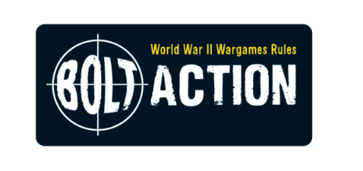
teamGenerals Outpost are hosting a Bolt Action tournament
“Bolt Action Doubles Tournament”
Saturday 16th May 2026
08:30-17:30
Denewell Ave URC Hall. Low Fell, Gateshead. NE9 5HD
£15 (free to club members)

64 Players, 16 Tables featuring theatres from the whole of WW2, three 150-minute games per team and…. Prizes, Prizes, Prizes (so far ~£700+ worth).

This will be our third tournament using 3rd edition rules.

One of the joys of Bolt Action is recreating historic units in miniature, as such we strongly encourage players to ‘theme’ their army around an actual WWII unit. Ideally, we’d like every army at this event to, so far as is possible, represent one that is plausible historically.

This means that if you want to do a specific unit at a specific time and place (such as John Frost’s Bn at Arnhem or a Panzer Zug from the 21st Panzer Division in 1941) then crack on and we’ll be suitably impressed! There is even a prize for ‘Best presented Army’.

All lists that are submitted by the deadline (Saturday 25th April 2026) will receive an additional 2 points towards their overall event standings. Lists submitted by Sunday 26th April will receive 1 additional point. After this date if we have not received your army lists, we will assume you are no longer interested in attending and could offer your place to someone on our reserve list, so don’t miss the deadline!

A Team comprises two players.
Both team members must select a legal force of no more than 750 points each, and a maximum of 11 order dice.

This will give a combined team force of 1500 points with a maximum of 22 order dice.

Teams do NOT need to select the same nation as each other. Go wild with your combinations for best battlefield effect.
Army effects only affect your half of the team, even if both members choose the same nation.
Special rules (such as snap-to) do not cross army divides. They only affect your army, not your ally. The only exception is Medics as they will help anyone from your team if in range.

Each game will be 150 minutes in length.

Each team will play 3 games on 6’x4’ themed tables.

Once time is called, no new Order dice may be drawn and all games cease at the end of the current Order dice activation – no further rounds are played, regardless of mission rules.

Each table will be set up with a mission already prepared on it. Each table will also have a mission card that explains the mission and any special rules it uses. Missions can come from any book, so choose your army wisely.

Picking your force
Begin by picking a nation from any of the countries currently represented in a Warlord Games publication (including pdfs) that are valid for 3rd edition (sorry no 2nd edition rules or books can be used). Next, pick a theatre, such as North African, Mediterranean, North-west European, Pacific, Eastern Front, etc. The list goes on, but obviously this must be a front where your chosen nation fought. Then pick a year. Again, obviously, a year where your chosen nation was fighting in your chosen theatre.

Finally, build your force using the platoon selectors available.

No limits on the maximum armour of any vehicle and no units are on the prohibited list provided they are legal within force selection.

There is a prize for the best presented individual army, however, **No offensive iconography on any units please**

When you submit your list include the following information:

- Team Name
- Team Player names
- Your Name
- Your army Nation
- Your army Theatre
- Your army Year
- Your army list, broken down by platoons used (any format is acceptable)

Remember: Force lists should be submitted to Chris for verification no later than Saturday 25th April to receive maximum bonus tournament points. And if you miss the 26^{th of} April deadline you could lose your place. Email all lists to cmbucknall@yahoo.co.uk
Event timings

Day1
08:00 Door open (please try to arrive before 08:30 for a prompt start)
08:30-08:35 housekeeping & event rules recap
08:35-08:45 setup for 1st game
08:45-11:15 Game 1
11:15-11:30 setup for game 2
11:30-14:00 Game 2
14:00-14:30 Lunch
14:30-14:45 setup for game 3
14:45-17:15 Game 3
17:15-17:25 Arena of Death (if needed)
17:25-17:30 Awards, photos
17:30 onwards Teardown, event ends.

SCORING SYSTEM The scoring system is as follows:

- 3 Points for a Win
- 2 Point for a Draw
- 1 Points for a Loss
+2 bonus points for army lists submitted before the deadline.
+1 bonus point for each half of your army that is fully painted and based.

Total Dice taken from the enemy will also be recorded to help split ties if needed.

Tournament games & ties for top/bottom places

After the three games have been played and in case of a tournament score tie for the top four tournament places (as these matter for prizes) the following will happen:

- Tied teams will enter the “arena of death” with their army generals. 2 order dice per team will be placed into the dice bag. Battle to the death amongst the army Generals. Think of the end scene of “The Good the Bad and the Ugly” and you are on the right track.

This will very quickly resolve any ties (and is great fun after the big battles have subsided)

Useful info

Address of event: Denewell Ave URC Hall. Low Fell, Gateshead. NE9 5HD

There is limited street parking on Denewell Ave. Please be respectful of blocking anyone’s access. Paid parking is available at Lowreys lane car park (NE9 5JB) which is only a short 5 min walk from the hall.

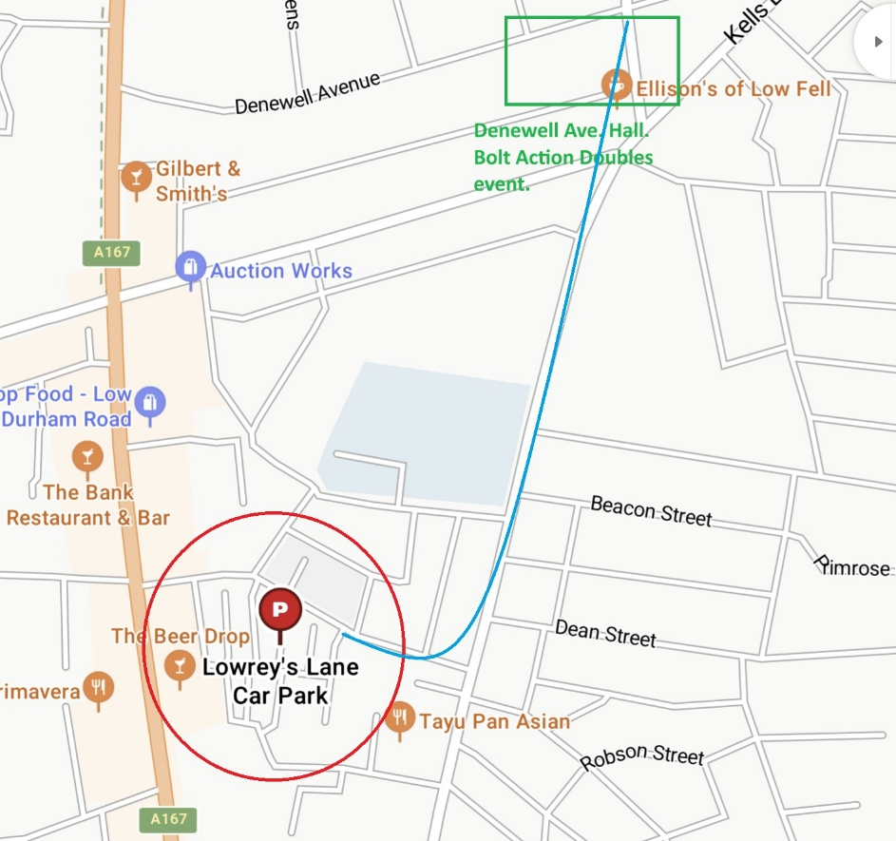

Event organiser: Chris Bucknall. 07703580449. cmbucknall@yahoo.co.uk

To book a place: Please call or email Chris ASAP if you would like to book a place. Latecomers may be offered a space on our reserve list.

Cost: £15pp (Teams are therefore £30) (free to club members)

Players will be assigned a random initial starting table on arrival.
After round one, draws for round two and three games will ensure that winners will play winners etc. so everyone should find their level on the final tournament leaderboard.

Tea, Coffee, juice and biscuits freely available throughout the day. Coffee machine using pods available (50p each).

Bring a packed lunch as no lunch is provided (Greggs and Co-op only 5 minutes away)

Trophies: We have four trophies to hand out:

- Tournament Winners (most points accumulated over three games).
- Most Sporting General (voted for by all players)
- Best presented army (voted for by all players over lunchtime)
- Most cinematic moment (voted for by players)

Prizes: The top 4 scoring tournament teams will win a prize as well as the four other special prizes.

Gecko Gaming

Local hobby store Gecko Gaming will also have a presence on site for the event. If you want Ollie to bring anything in particular, please let Chris know.
Prizes

Issue Order Prize

Big Box Randomly weighted winner based on tournament points (may choose any other prize)

Winning team 1st Pick, Silver Bolt Action trophy, gold club dice for each player, pack of Golden Order Dice for each player, Special event miniature for each team member

Most sporting player 2nd Pick, Special event miniature, as voted for by players.

Best presented army 3rd Pick, Special event miniature, as voted for by players.

2nd Place 4th Pick, Silver Bolt Action trophy, silver club dice for each player, Special event miniature for each team member

3rd Place 5th Pick, Bronze Bolt Action trophy, bronze club dice for each player

4th Place 6th Pick

FUBAR Multiple silver Dice bags. Self-nominations on each FUBAR event. (Player self-nominations)

Best U18 team 7th Pick

Most cinematic Moment Player self-nominations. 8th Pick

Last Place Wooden Spoon, 9th Pick.

Generals Outpost Doubles May 26’

Game: 1

Victory Conditions: Key Positions p164

Deployment Zone: Long Edges p169

Deployment Type: Prepared Positions p170

Special rules: 5 Objectives (pre-set on each table), hold the most to win the game. Objectives are not sticky. Preparatory bombardment p175 (Roll once for both players, it arrives for everyone or not at all)

Generals Outpost Doubles May ‘26

Game: 2

Victory Conditions: Seek and Destroy p164

Deployment Zone: Long Edges p169

Deployment Type: Meeting Engagement p170

Special rules: -

Generals Outpost Doubles May ‘26

Game: 3

Victory Conditions: ?

Deployment Zone: ?

Deployment Type: ?

Special rules: ?

